PRESS RELEASE

Search Sarkari Naukri Launches Comprehensive Government Jobs, Exam Updates & Daily Assessment Platform for Indian Aspirants
Pune, Maharashtra, India – Search Sarkari Naukri, a fast-growing government job and competitive exam preparation platform, has officially expanded its services to help job seekers, students, and competitive exam aspirants access the latest government jobs, exam notifications, admit cards, results, current affairs, and daily assessments from a single platform.
With increasing competition in government recruitment and millions of candidates preparing for UPSC, MPSC, SSC, Banking, Railway, Police Bharti, Teaching, and State Government examinations, Search Sarkari Naukri aims to simplify the job search and exam preparation journey through a centralized and user-friendly platform.
The platform provides real-time updates on government recruitment opportunities across India while also offering educational resources designed to improve candidate preparation and success rates.

A Complete Government Jobs and Exam Information Platform
Search Sarkari Naukri has been developed to address the challenges faced by job seekers who often struggle to find accurate and timely recruitment information from multiple sources.
The platform offers:
- Latest Government Jobs
- Sarkari Naukri Notifications
- UPSC Updates
- MPSC Updates
- SSC Recruitment
- Banking Jobs
- Railway Jobs
- Police Bharti Notifications
- Teacher Recruitment Updates
- Admit Cards
- Sarkari Results
- Exam Calendar
- Current Affairs
- Daily Quiz
- Daily Assessment
- Career Guidance
- Eligibility Checker
- Age Calculator
- Digital Library
By organizing recruitment information into qualification-wise, department-wise, district-wise, and location-based categories, Search Sarkari Naukri enables users to quickly discover relevant opportunities based on their educational background and career goals.

Daily Assessment for UPSC & MPSC Aspirants
One of the platform's newest features is the Daily UPSC & MPSC Assessment System.
This feature allows candidates to solve daily questions based on:
- Current Affairs
- General Studies
- UPSC Preparation
- MPSC Preparation
- Government Exam Practice
The assessment system is designed to build consistency and improve exam readiness through daily practice and performance tracking.
Candidates can access the assessment platform here:
- Daily Assessment: https://www.searchsarkarinaukri.com/daily-assessment
- Daily Quiz: https://www.searchsarkarinaukri.com/quiz
- Current Affairs: https://www.searchsarkarinaukri.com/current-affairs

Smart Tools for Government Job Aspirants
Search Sarkari Naukri goes beyond traditional job listings by providing several free tools to assist candidates throughout their preparation journey.
Key tools include:
Eligibility Checker
https://www.searchsarkarinaukri.com/eligibility-checker
Helps candidates identify government jobs matching their qualifications.
Age Calculator
https://www.searchsarkarinaukri.com/age-calculator
Provides accurate age calculations and category-based age relaxation information.
Career Guidance
https://www.searchsarkarinaukri.com/career-guidance
Offers guidance for selecting suitable exams and career paths.
Digital Library
https://www.searchsarkarinaukri.com/digital-library
Provides study materials and educational resources for exam preparation.

Location-Based Government Job Search
To improve discoverability and user experience, Search Sarkari Naukri has built a structured job discovery system that enables users to browse opportunities based on:
- State
- District
- Qualification
- Department
- Exam Category
- Recruitment Organization
Users can explore government jobs by district through:
https://www.searchsarkarinaukri.com/districts
This feature is particularly useful for candidates seeking local government employment opportunities in Maharashtra and across India.

Real-Time Job Alerts and Community Updates
The platform also provides instant government job alerts through dedicated WhatsApp and Telegram communities, ensuring that candidates never miss important recruitment notifications.
Users can subscribe to:
- Government Job Alerts
- Admit Card Notifications
- Result Announcements
- Exam Updates
- Current Affairs Updates
Job Updates Page:
https://www.searchsarkarinaukri.com/job-updates

Focus on Accuracy and User Trust
Search Sarkari Naukri emphasizes accuracy, transparency, and accessibility. The platform continuously updates recruitment information and educational content while maintaining a clear disclaimer that it is not affiliated with any government organization.
The objective is to provide candidates with a reliable source of information while simplifying the process of finding government jobs and preparing for competitive examinations.

Growing Digital Infrastructure
The platform features dedicated sections for:
- All Government Jobs
- All Competitive Exams
- Admit Cards
- Results
- Government Job News
- Blogs
- Current Affairs
- Exam Calendar
Explore:
- Jobs: https://www.searchsarkarinaukri.com/jobs
- Exams: https://www.searchsarkarinaukri.com/exams
- Results: https://www.searchsarkarinaukri.com/results
- Admit Cards: https://www.searchsarkarinaukri.com/admit-cards
- News: https://www.searchsarkarinaukri.com/news
- Blogs: https://www.searchsarkarinaukri.com/blogs

About Search Sarkari Naukri
Search Sarkari Naukri is an Indian government jobs and competitive examination platform dedicated to helping candidates discover government recruitment opportunities, exam updates, admit cards, results, current affairs, and preparation resources.
The platform serves students, fresh graduates, job seekers, and competitive exam aspirants across India through a structured ecosystem of job discovery, exam information, assessment tools, and educational resources.
Website: https://www.searchsarkarinaukri.com

Media Contact
Search Sarkari Naukri
Office No. 205, Wakadkar Complex,
Near IT Park, Wakad,
Pune – 411057, Maharashtra, India
Email: info@searchsarkarinaukri.com
Mobile: +91 9960515757
Website: https://www.searchsarkarinaukri.com

IMG -1
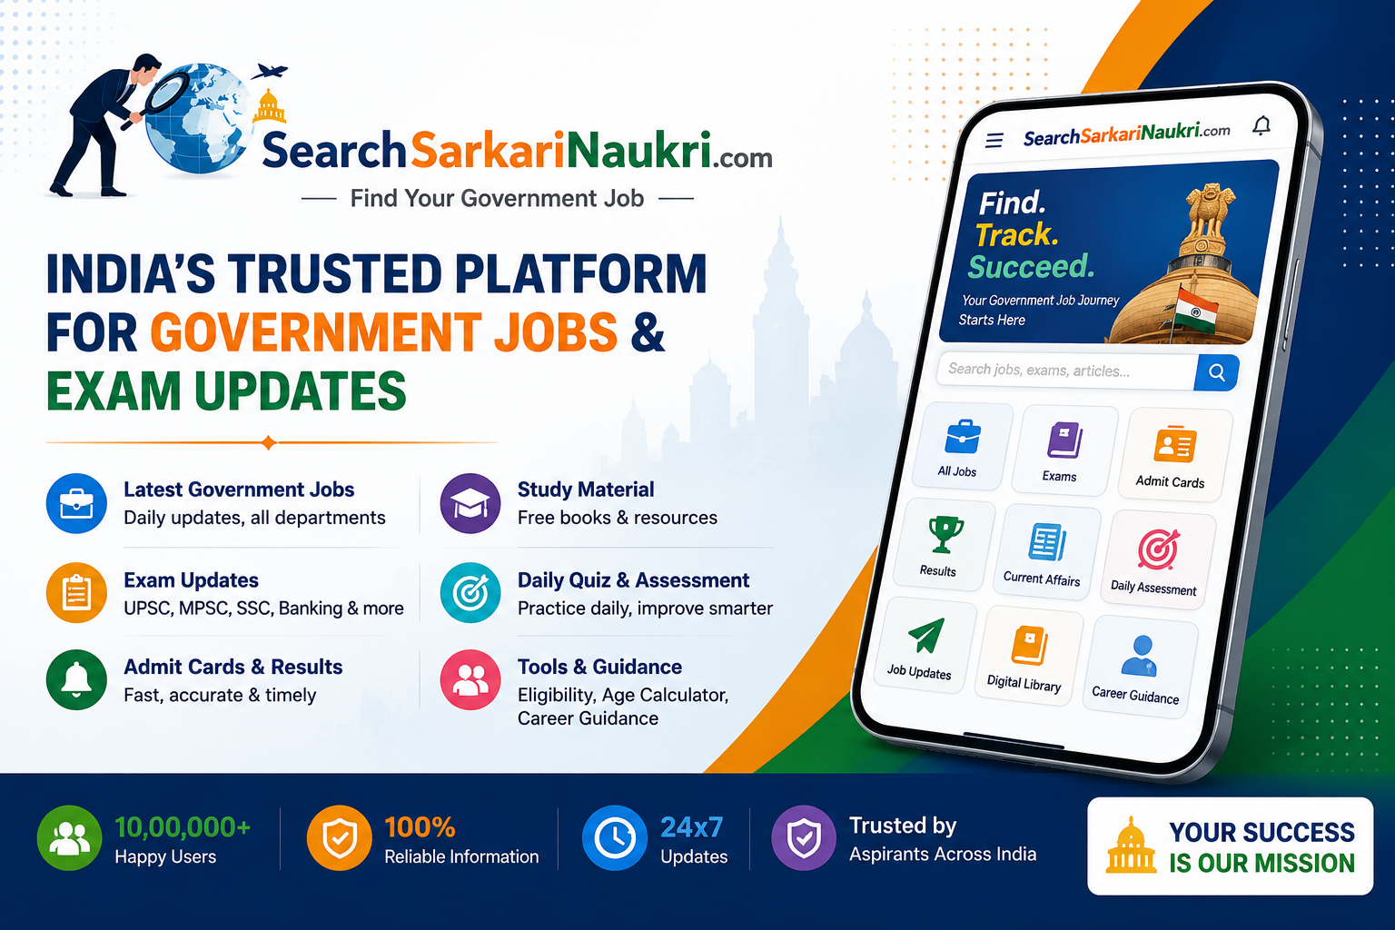

IMG -2
